Excellence Foundation Awards Spring Grants - 2019

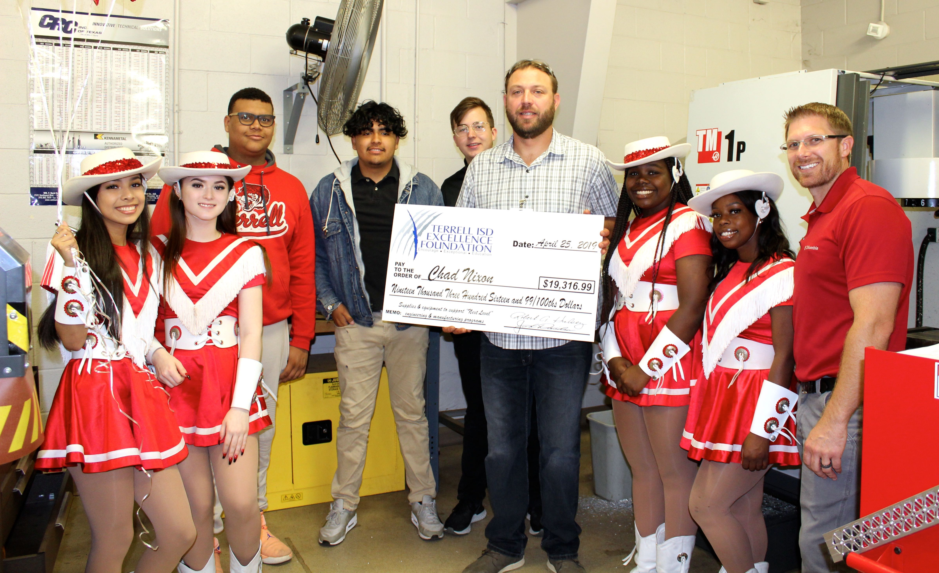

One of the largest grants awarded this spring was to THS Manufacturing-Engineering instructor Chad Nixon. Equipment and supplies are needed to implement “Next Level” engineering programs and to provide support for THS Manufacturing Technology students. The Excellence Foundation presented a check to Mr. Nixon for $19,316.99.

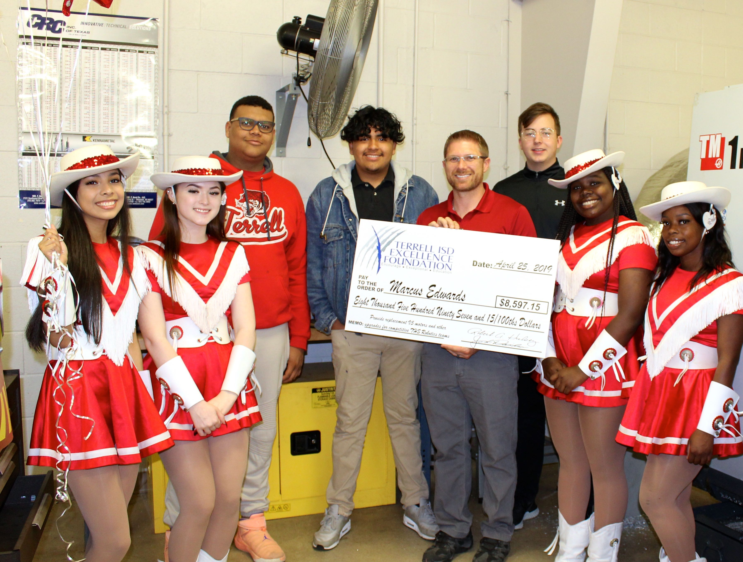

Marcus Edwards, THS Robotics-Engineering instructor, encourages his students to excel in science, technology, engineering, arts, and math (STEAM) through his robotics program. Mr. Edwards received a grant for $8,597 to upgrade and replace old and worn out robotics equipment.

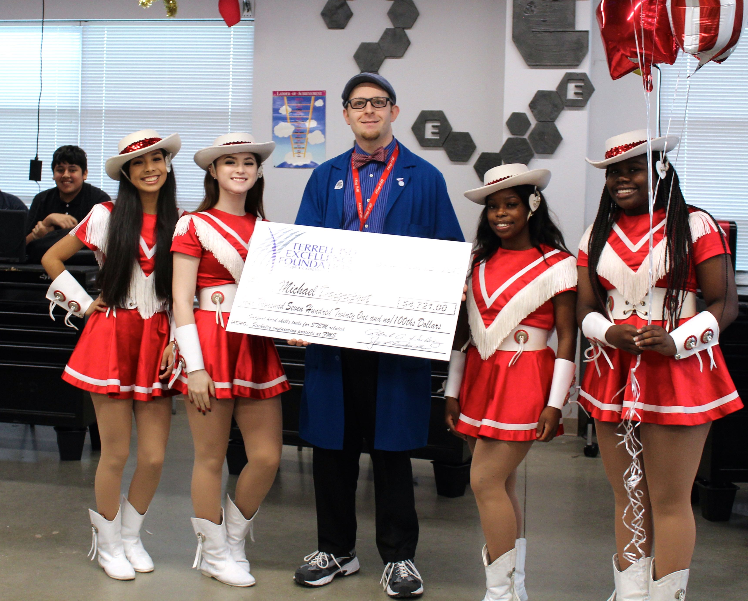

Mr. Michael Daigrepont of Furlough Middle School requested tools and equipment to equip an after-school program to support STEM related rocketry projects. Daigrepont received $4,721 to fund this program, which will provide hands-on experiences for students to gain hard skills for tools and engineering that are not addressed in regular classes.

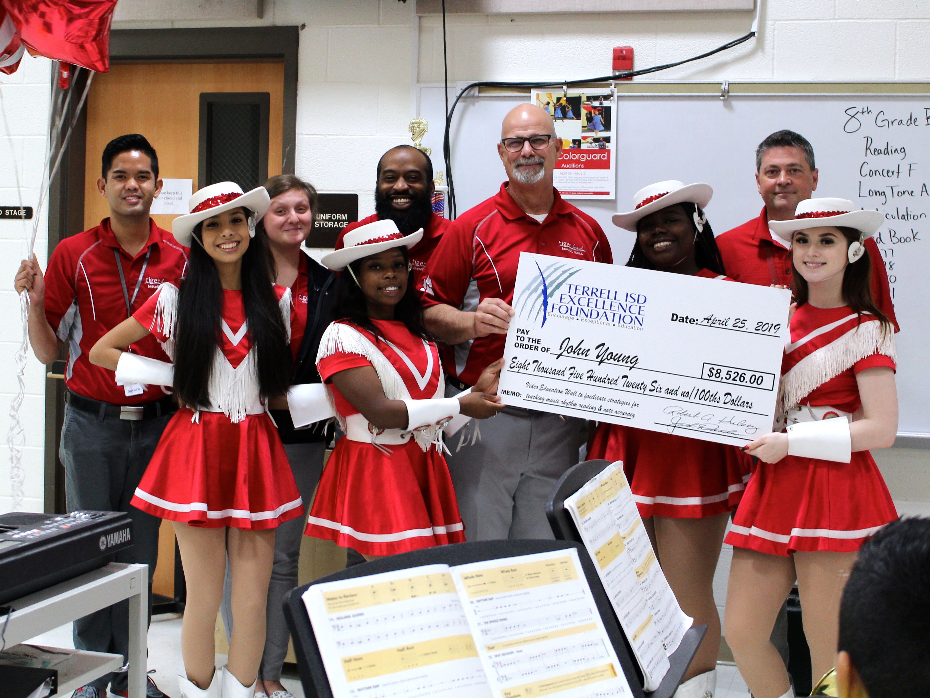

Mr. John Young received a grant of $8,526 to purchase video equipment and software for Furlough Middle School band students to enhance playing in rhythm, in tune, and with note accuracy in large ensemble settings.

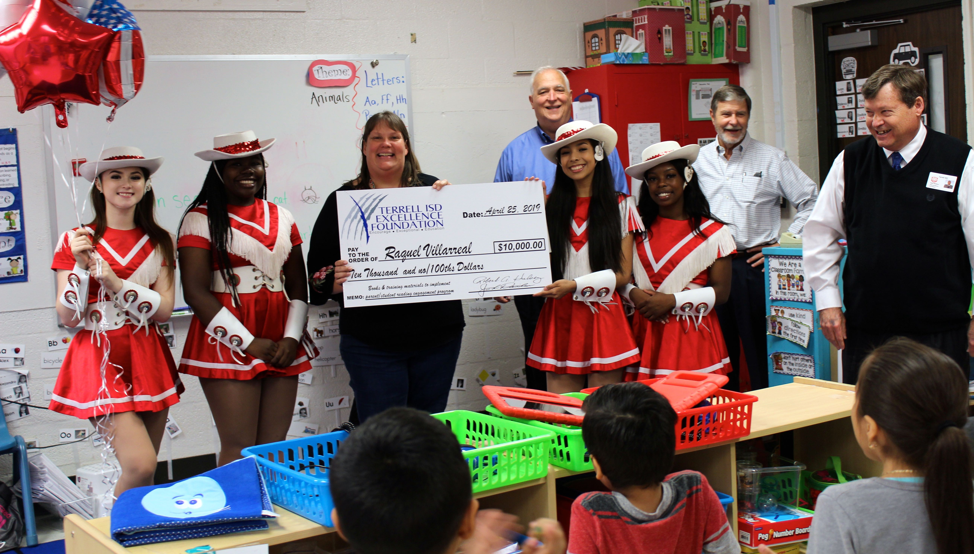

Raqueal Villarreal, principal of Burnett, received $10,000 to fund a program for Burnett Elementary to purchase books and parent training materials to encourage parent involvement with their child's literacy and emotional health. Teacher Robin Cannon received the grant from the Excellence Foundation.

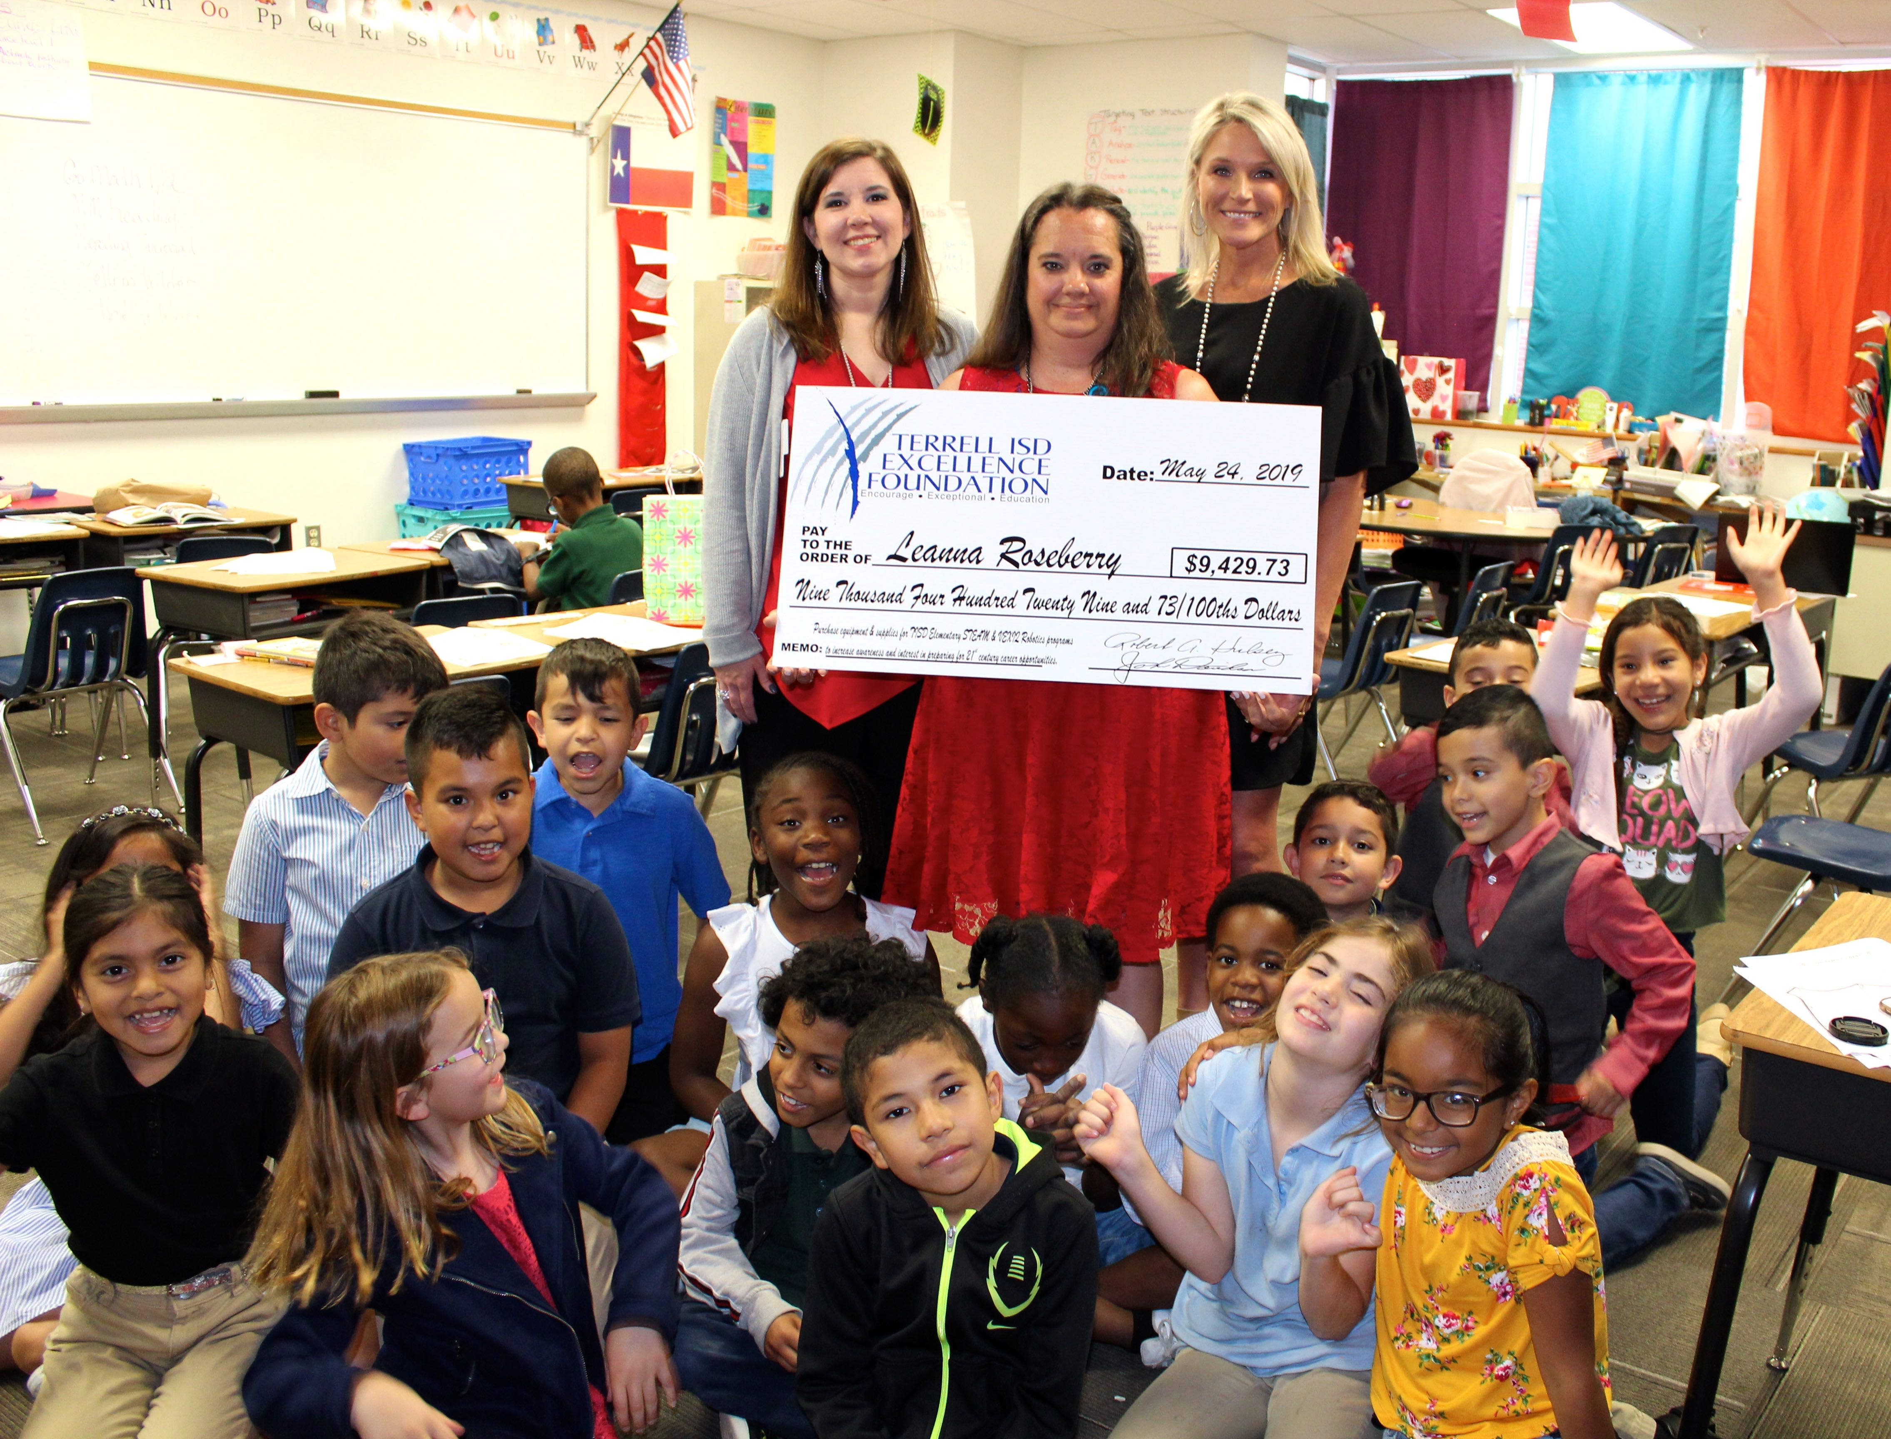

Leanna Roseberry coordinated a grant that will benefit Long and Willie Elementary Schools, as well as the new Global Leadership Academy. She received $9,429 to purchase equipment, software, and supplies to support STEAM & VEX Robotics participation.

